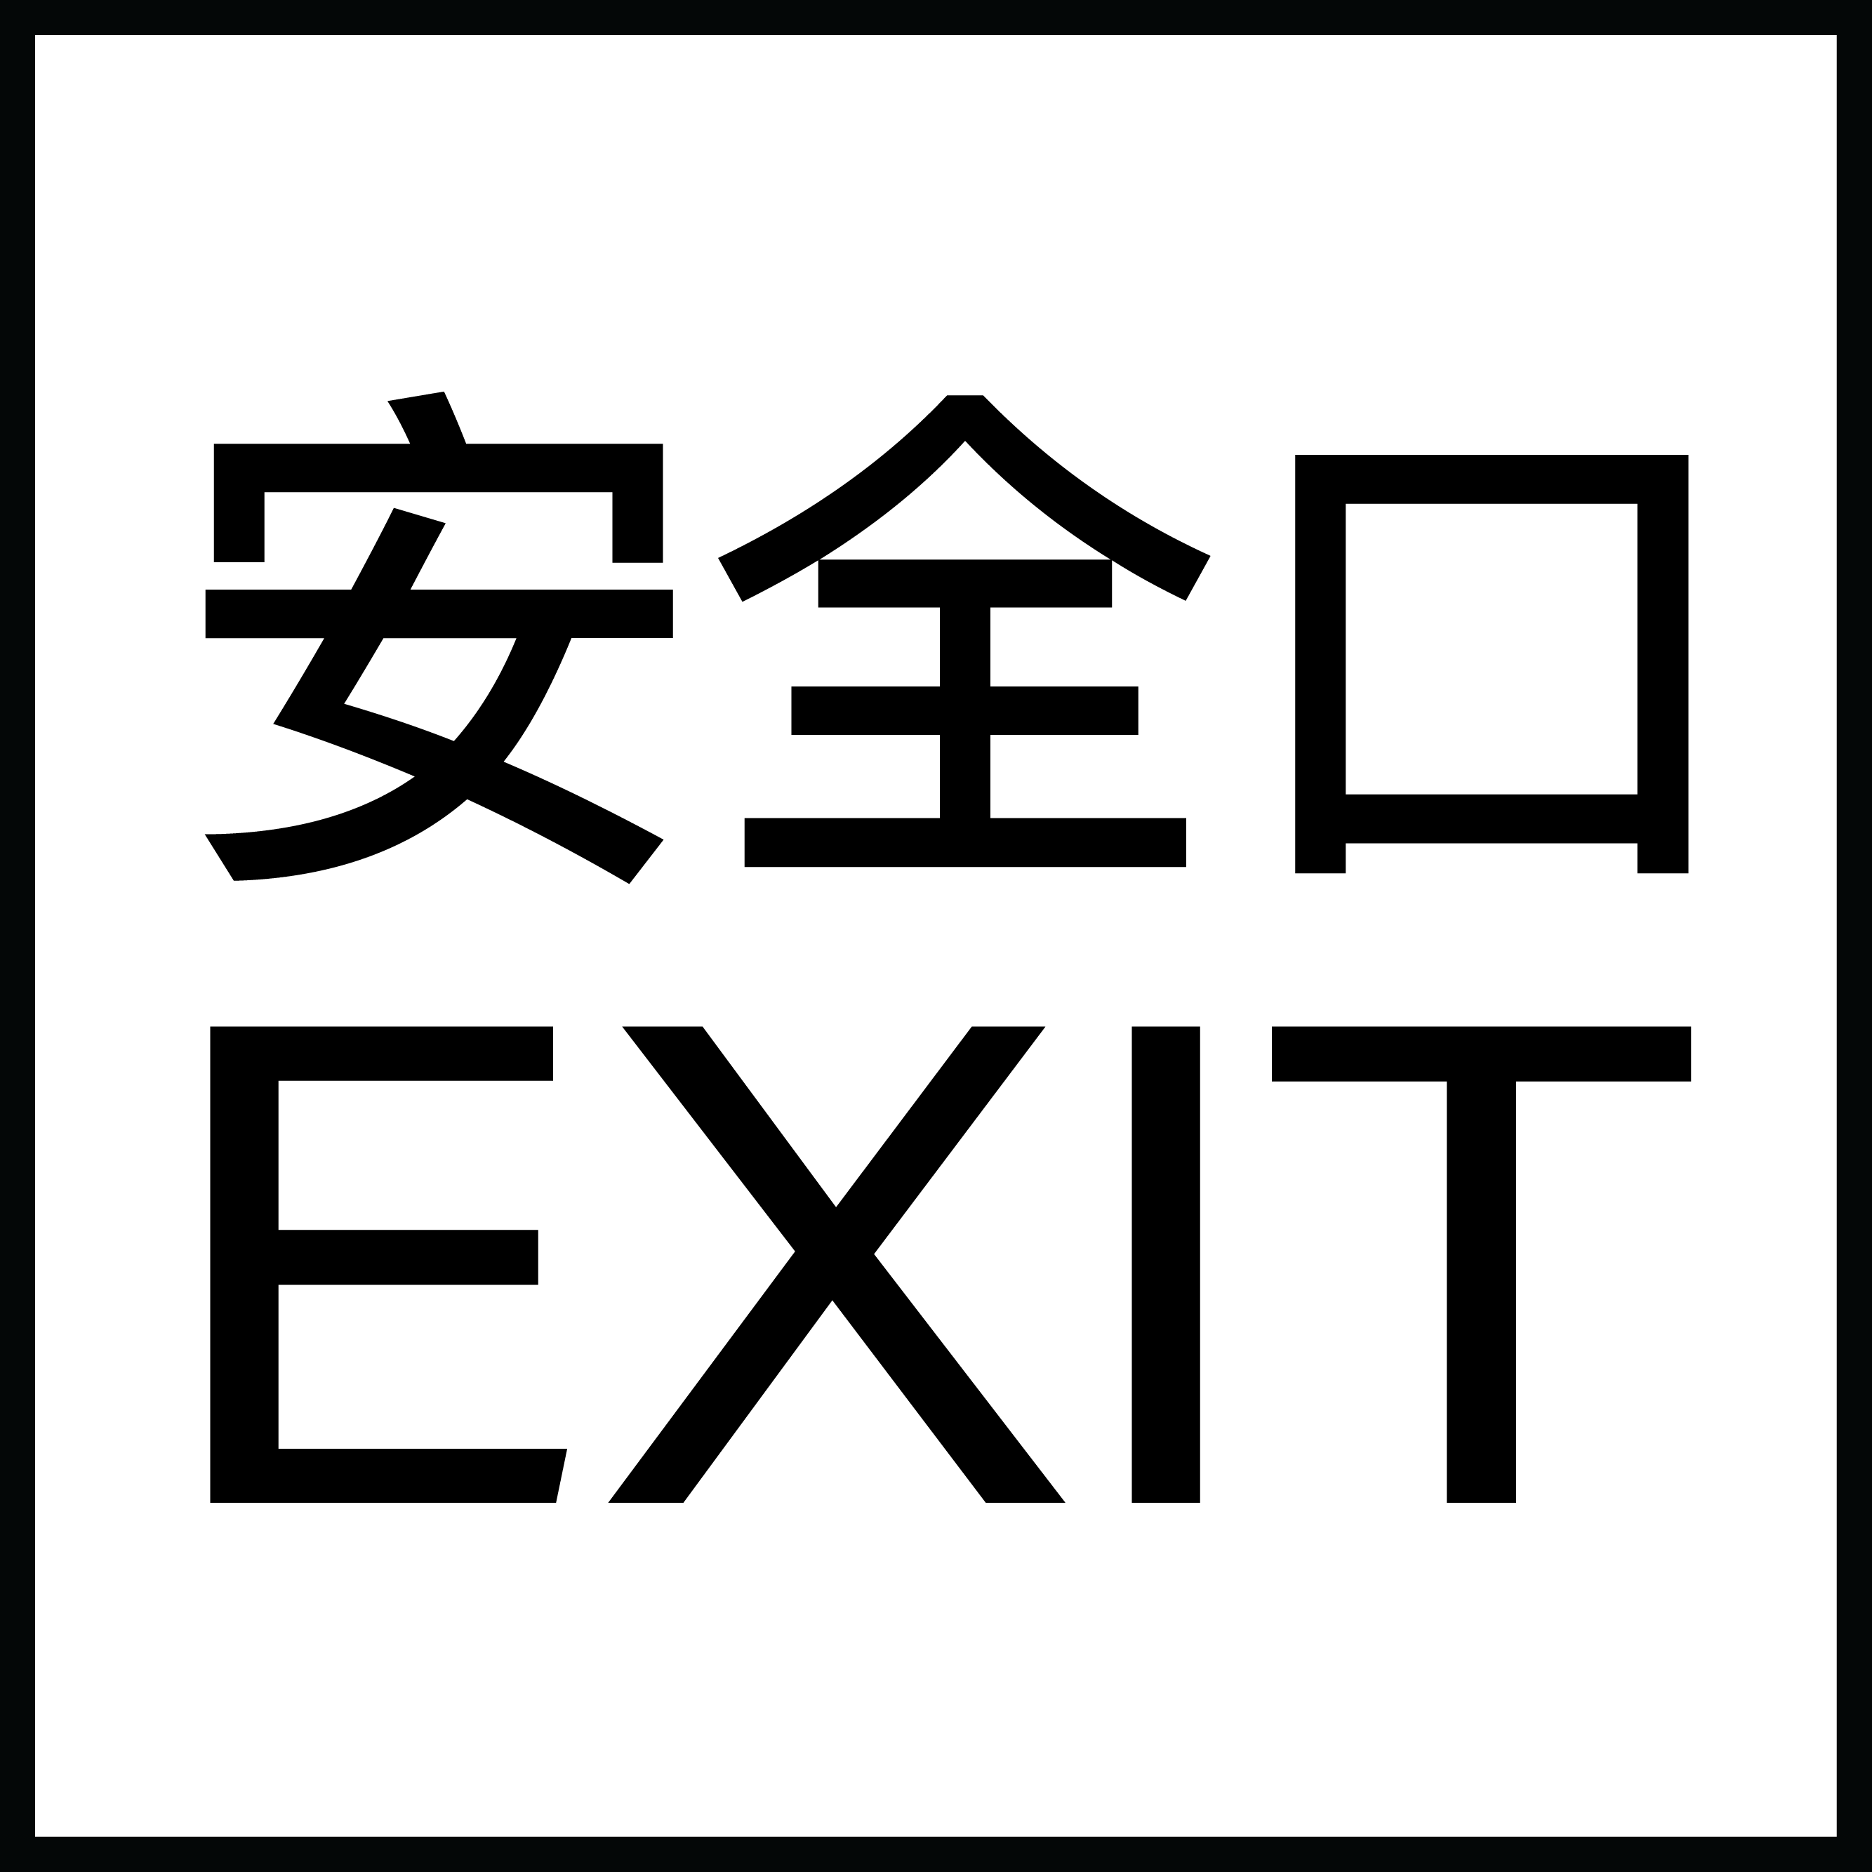

JEONG Yun Kyung : Dash and Symphony

11 July – 8 August 2020
Opening: Saturday, 11 July 2020, 2 - 5 pm
EXIT, 3/F, 25 Hing Wo Street, Tin Wan, Aberdeen, Hong Kong
Hours: Tue - Sat, 11am-6pm

Gallery EXIT is pleased to present solo exhibition "Dash and Symphony” by JEONG Yun Kyung, the London based Korean artist’s first solo in Hong Kong. The exhibition will open on 11 July 2020 and remain on view through 22 August 2020. An opening reception will be held on Saturday, 11 July from 2pm to 6pm.

JEONG practices deviated from the East-Asian ink traditions and aesthetics, combining meticulous inkscape with dynamic strokes of abstract expressionism. Her works experiment with the spatial space and symbolic representation, with vivid colour intertwine with the tranquil and orderly geometric structures beneath, balancing between completeness with blankness.

Some of JEONG’s recent paintings such as “ICEE” and “Blooming Eggs” employs metaphorical elements from domestic settings, simulate the movement and structure of the physical space. The series of works symbolise the human perspectives, depicting the moment when breaking into the wilderness.

In “The Given” and “The Given II”, The smooth luminous lines travel within the delicate space of repeating motifs and collage textures. The bold lines and strokes, either continuous and abruptly, is the artist’s attempt to juxtapose between different spaces, both digitally and physically.

About the artist

JEONG Yun Kyung (b. 1981, Incheon) graduated from The Slade School of Fine Art with a Master of Fine Arts in 2008, and a Bachelor of Arts degree from the College of Art Design at Ewha Womans University in 2006. Her works have been widely exhibited internationally. Solo exhibitions include “Intimate Immensity” (Triumph Gallery, Moscow, 2018), “Structural Sensibility” (Art’Loft, Brussels, 2016), “In-Sync” (Gallery Koo, Seoul, 2015) and “. Selected group exhibitions include “Asia Now Paris” (Art’s Loft/Lee-Bauwens Gallery, Paris, 2019), “Lines of Flight” (Gallery EXIT, Hong Kong, 2016). JEONG was one of the finalists of “The Columbia Threadneedle Prize” in 2012 and the “Joongang Fine Art Prize” in 2008. Her works are part of art collections such as “Tiroche DeLeon Collection”, “National Museum of Modern, Contemporary Art, Korea” and “OCI Museum of Art”, Seoul. JEONG currently lives and works in London.

鄭潤慶《破折的韻流》

2020年7月11日至8月22日
開幕：7月11日(星期六)下午2時至6時
地點：安全口畫廊 香港香港仔田灣興和街25號 大生工業大廈 3樓
辦公時間：星期二至六上午11時至下午6時

安全口畫廊呈獻韓裔藝術家鄭潤慶於香港的首個個展《破折的韻流》。展覽於2020年7月11日至8月22日開放，開幕酒會在7月11日（星期六）下午2時至6時舉行。

鄭潤慶結合了東亞水墨傳統與當代抽象藝術的表現手法，作品揉合細緻的水墨景像和抽象表現主義的動態筆觸。她的作品充滿強烈的反差，奔放的色彩呈現於未經加工的畫布上。藝術家以渾灑的筆觸令觀者的視線從靜謐重複性的幾何結構中更迭。

鄭潤慶的近作《ICEE》及《Blooming Eggs》從現實的居家空間攝取靈感，重構物質世界的形態和規律。畫中斑斕的視覺原素喻意人類與大自然的博奕。

新作《Given》和《Given II》中噴墨般光滑的線條穿插於細緻如禪繞般的構圖和拼貼中。鄭潤慶以靈動的線條，連綿不斷或斷斷續續，把現實及電子屏幕的創作空間和畫面連繫起來。

關於藝術家

鄭潤慶（1981，首爾），2008年及2006年分別畢業於倫敦大學學院斯萊德美術學院碩士學位及梨花女子大學藝術學院學士學位。她的作品在國際上廣泛展出，參與展覽包括個展《Intimate Immensity》（Triumph Gallery，莫斯科，2018）、《Structural Sensibility》（Art’Loft，布魯塞爾，2016）、《In-Sync》（Gallery Koo，首爾，2015）、聯展《巴黎亞洲藝博會》（Art’Loft，巴黎，2019）及《逃逸線》（安全口畫廊，香港，2016）。鄭氏分別於2012年及2006獲選入圍「哥倫比亞-創利德獎」及「Joongang藝術大賽」。她的作品被帝豪奇德隆收藏館、韓國國立當代藝術博物館及韓國首爾OCI美術館收藏。鄭氏現居於倫敦。

